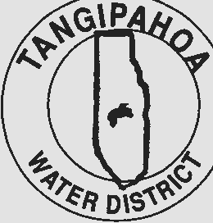

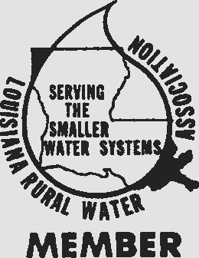
TANGIPAHOA WATER DISTRICT

Post Office Box 699 • Natalbany, Louisiana 70451 Natalbany: (985) 345-6457
Kentwood: (985) 229-6671
Fax: (985) 345-9422

BOIL ADVISORY
Tangipahoa Water District
PWSID1105008
September 10, 2018
For Immediate Release

The Tangipahoa Water System has issued a Temporary Precautionary Boil Advisory for a portion of distribution. The area affected is as follows:

Veterans Blvd, from Club Deluxe Rd. south to Doctors Blvd, including Lamonte Dr. and DeMarco Ln , due to break in the line.

Due to the situation discussed above, the water produced by our water supply system may be of questionable microbiological quality. Therefore, as a precaution, the Tangipahoa Water District is issuing a BOIL ADVISORY effective, immediately. This BOIL ADVISORY is to remain in effect until rescinded by the Water District.

It is recommended that all consumers disinfect their water before consuming it (including fountain drinks), making ice, brushing teeth, or using it for food preparation or rinsing of foods by the following means:

Boil water for one (1) full minute in a clean container. The one minute starts after the water has been brought to a rolling boil. (The flat taste can be eliminated by shaking the water in a clean bottle, pouring it from one clean container to another, or by adding a small pinch of salt to each quart of water that is boiled.)

Again, please be sure to disinfect your own water prior to consumption until you have been advised otherwise. The Water System will rescind this Boil Advisory upon notification from the Louisiana Department of Health and Hospitals - Office of Public Health that additional water samples collected from our water supply system have shown our water to be safe.Any further questions please contact, Tangipahoa Water District 985-345-6457.

